# **1 INTRODUCTION**

## **1.1 OVERVIEW**

The Air Transportation Analysis project aims to leverage Tableau's powerful data visualization capabilities to gain valuable insights and make informed decisions within the aviation industry. This project focuses on various aspects of air transportation, including route optimization, passenger demographics, and operational efficiency.

## **1.2 PURPOSE**

Analyze historical flight data to identify routes with high demand and potential profitability. Optimize existing routes and explore opportunities for new ones.Collect operational data such as aircraft utilization, maintenance records, and fuel consumption. This information may come from internal airline systems.

# **2 Problem Definition & Design Thinking**

## **2.1 Empathy map**

## 

## **2.2 Ideation & Brainstorming map**

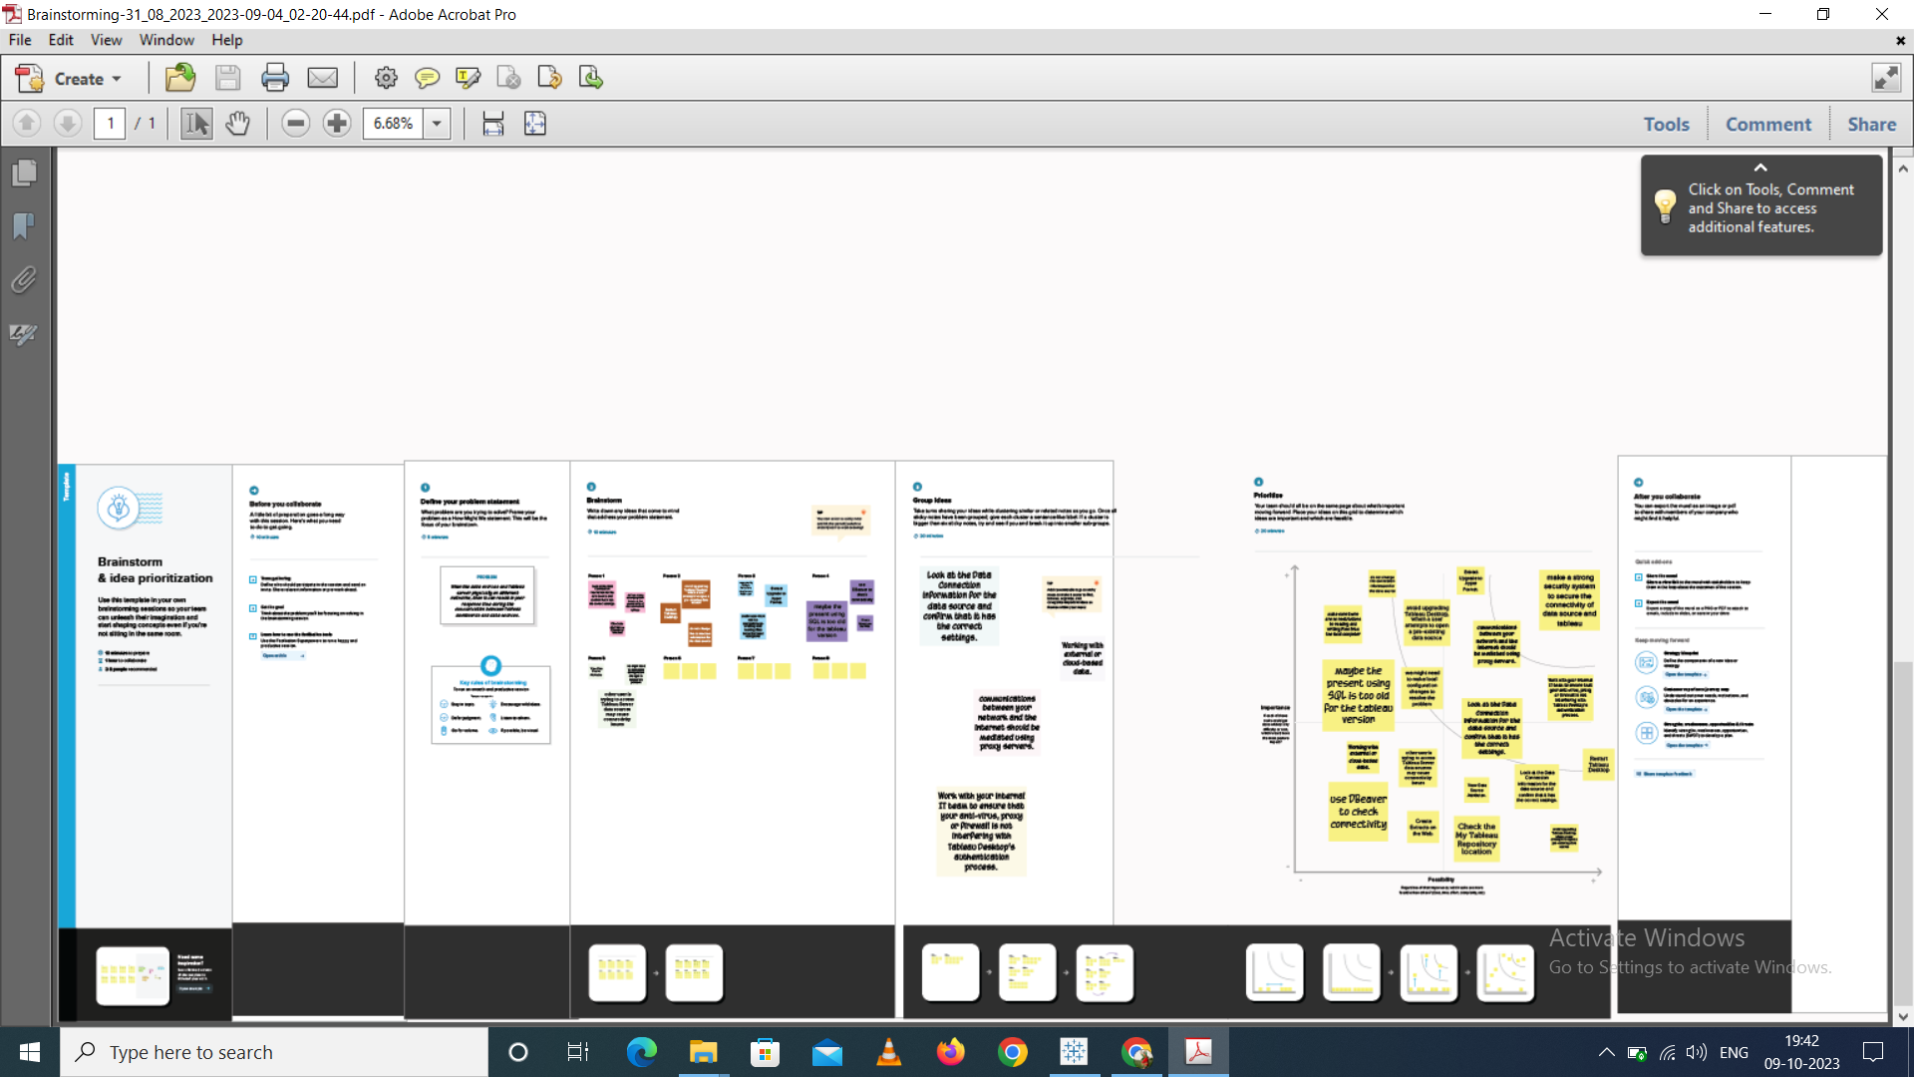

# **3 RESULT**

The project will empower stakeholders with actionable insights and facilitate data-driven decision-making in the air transportation industry.

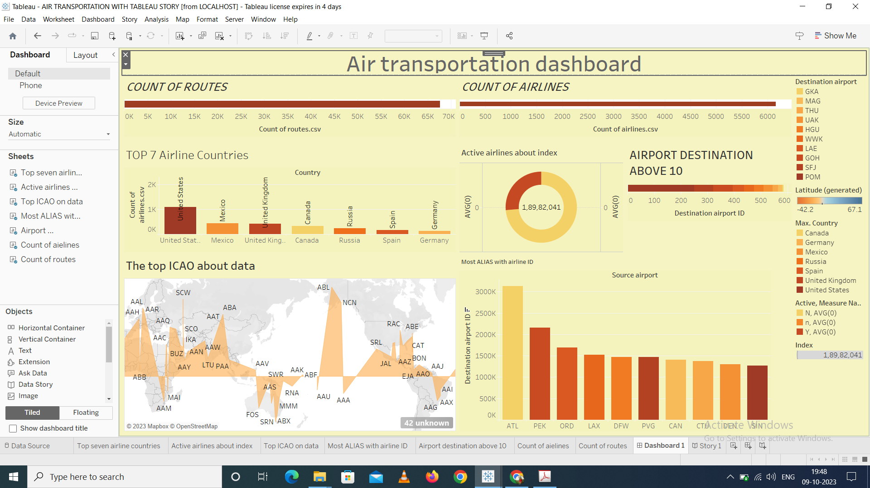

# **4 Advantages & Disadvantages**

### **4.1 Advantages**

### Geospatial Analysis: Tableau's geospatial capabilities enable the visualization of flight routes, airport locations, and passenger flows on maps, providing a comprehensive view of the air transportation network.

Scalability: Tableau can handle large datasets and is scalable to accommodate growing data needs, which is essential in the data-rich aviation industry.

### **4.2 Disadvantages**

Limited Advanced Analytics: Tableau is primarily a data visualization tool, and while it offers some basic analytics capabilities, it may not be suitable for advanced statistical analysis or machine learning tasks. Additional tools may be needed for these purposes.

Data Preparation: Data preparation can be time-consuming and may require cleaning, transformation, and normalization before analysis in Tableau. This can be a significant challenge, especially with complex aviation data.

# **5 Application**

## Improved Route Planning: By analyzing historical data, the project aims to provide insights that will lead to more efficient and profitable route planning for airlines.

## Enhanced Passenger Experience: Understanding passenger demographics can help airlines tailor their services and marketing efforts to meet customer preferences.

## Operational Efficiency: By analyzing operational data, airlines can identify areas for improvement, reduce costs, and optimize resource allocation.

# **6 Conclusion**

The Air Transportation Analysis project using Tableau is designed to leverage data visualization and analysis to enhance route optimization, passenger experience, and operational efficiency within the aviation industry. It combines data from various sources and uses Tableau's capabilities to create informative visualizations and support strategic decision-making.

# **7 Future scope**

This project will cover the following key areas:

* Data Acquisition: Collecting and preparing relevant data sources for analysis.
* Data Analysis: Utilizing Tableau's capabilities to analyze and visualize data.
* Insights Generation: Deriving actionable insights from the visualizations.
* Reporting: Creating reports and dashboards to communicate findings.

## 

### 